**CS571-Week2-Huijuan Xie-19893**

**CS571-Week2-q8-Huijuan Xie-19893**

Set up environment:  
Because I am using macOS, thus I am using Homebrew to install node

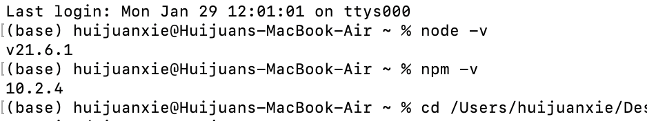

Using code from the page <https://hc.labnet.sfbu.edu/~henry/npu/classes/javascript/node_js/course/nodeschool/learnyounode/time_server.html>

I created file call “time_server.js”

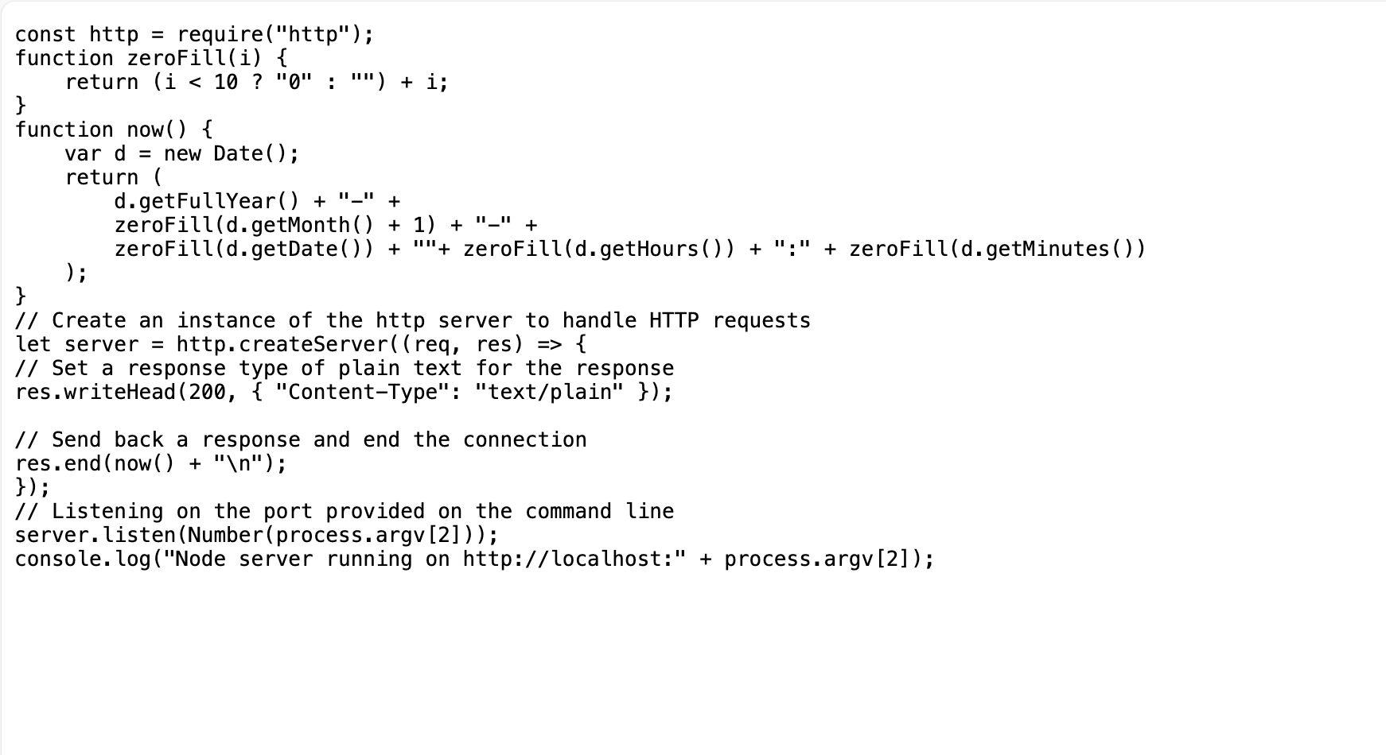

Start node time server:

Run the javascript file by the command

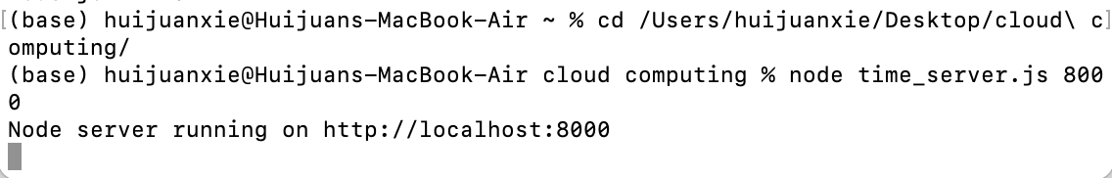

Open link http://localhost:8000 in Chrome browser.

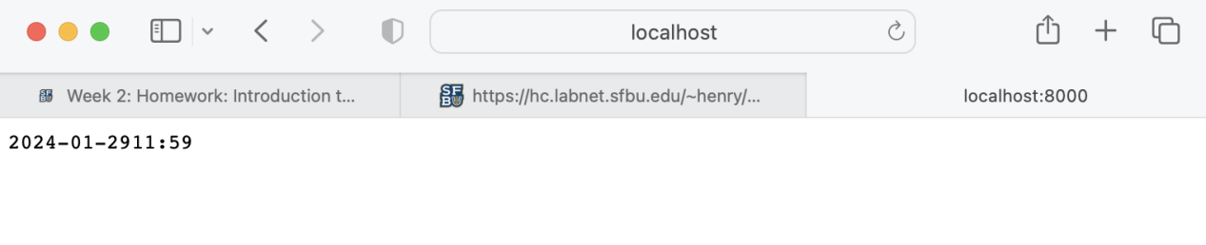

Option 2:  
I also tried the script in GCP Ubuntu  
I created a new instance, the IP is 34.136.98.1

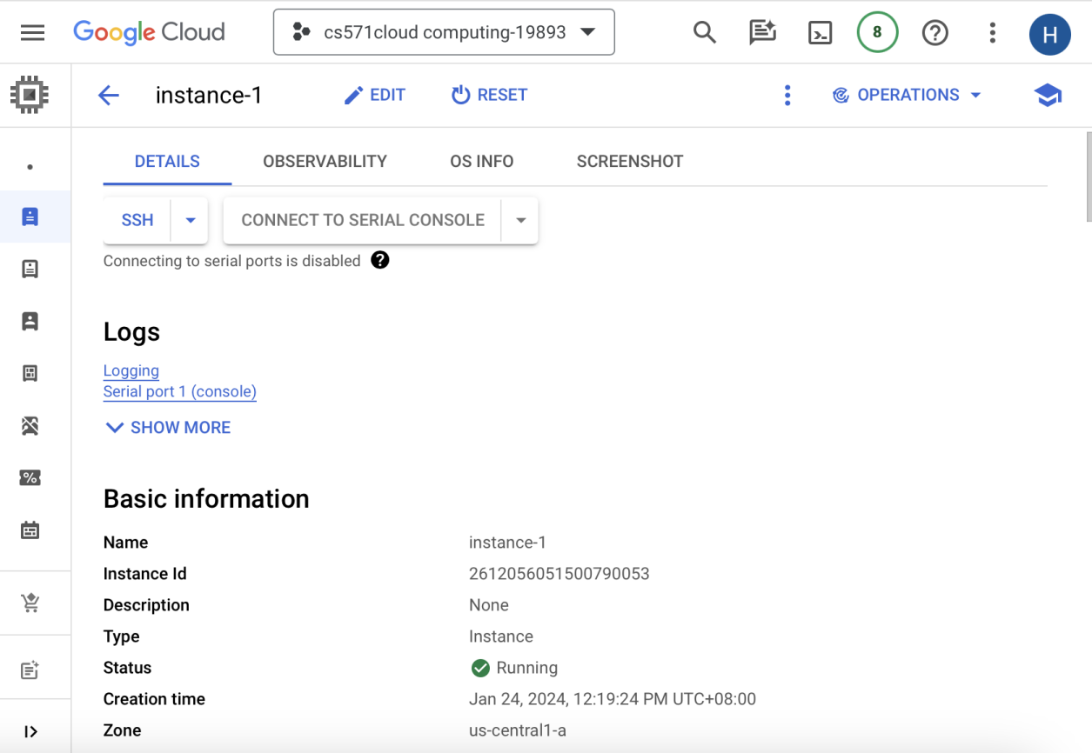

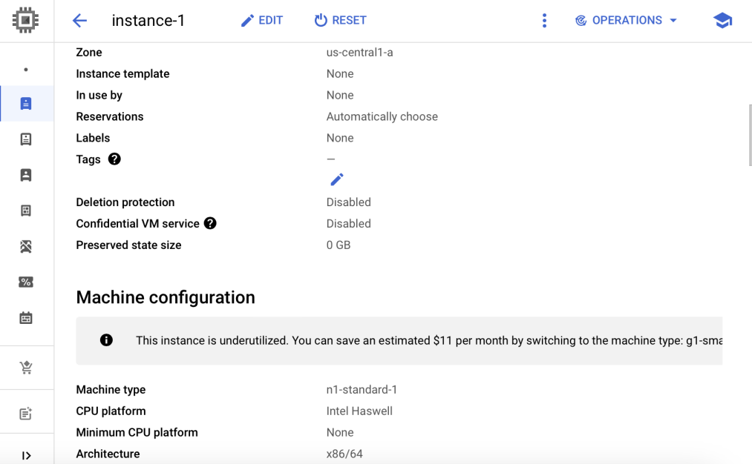

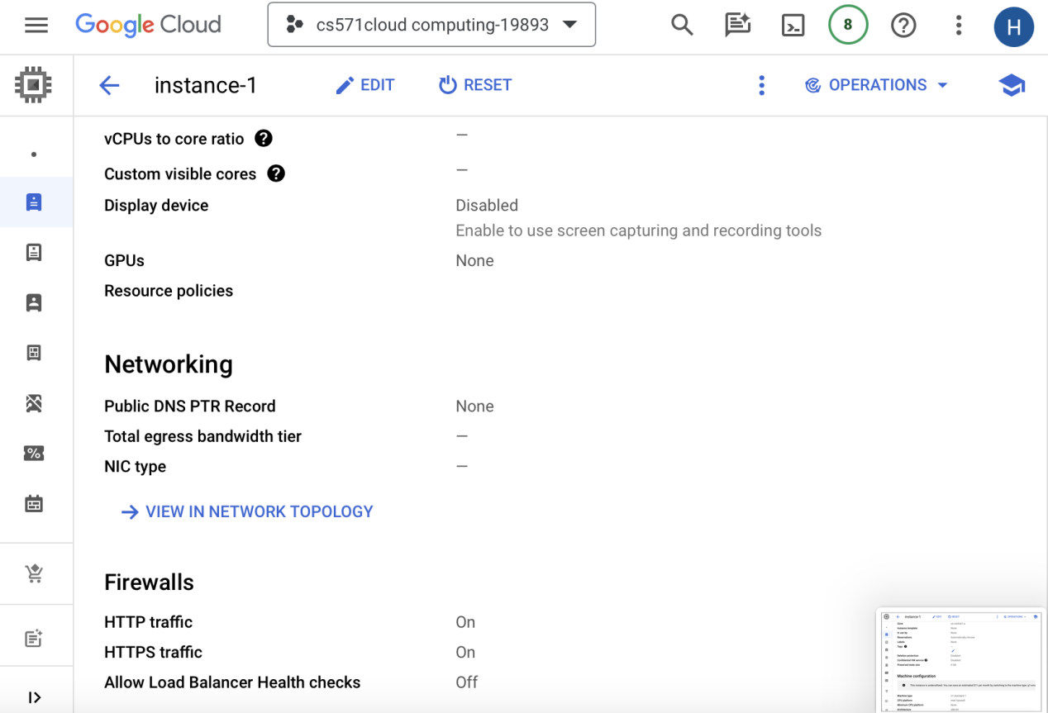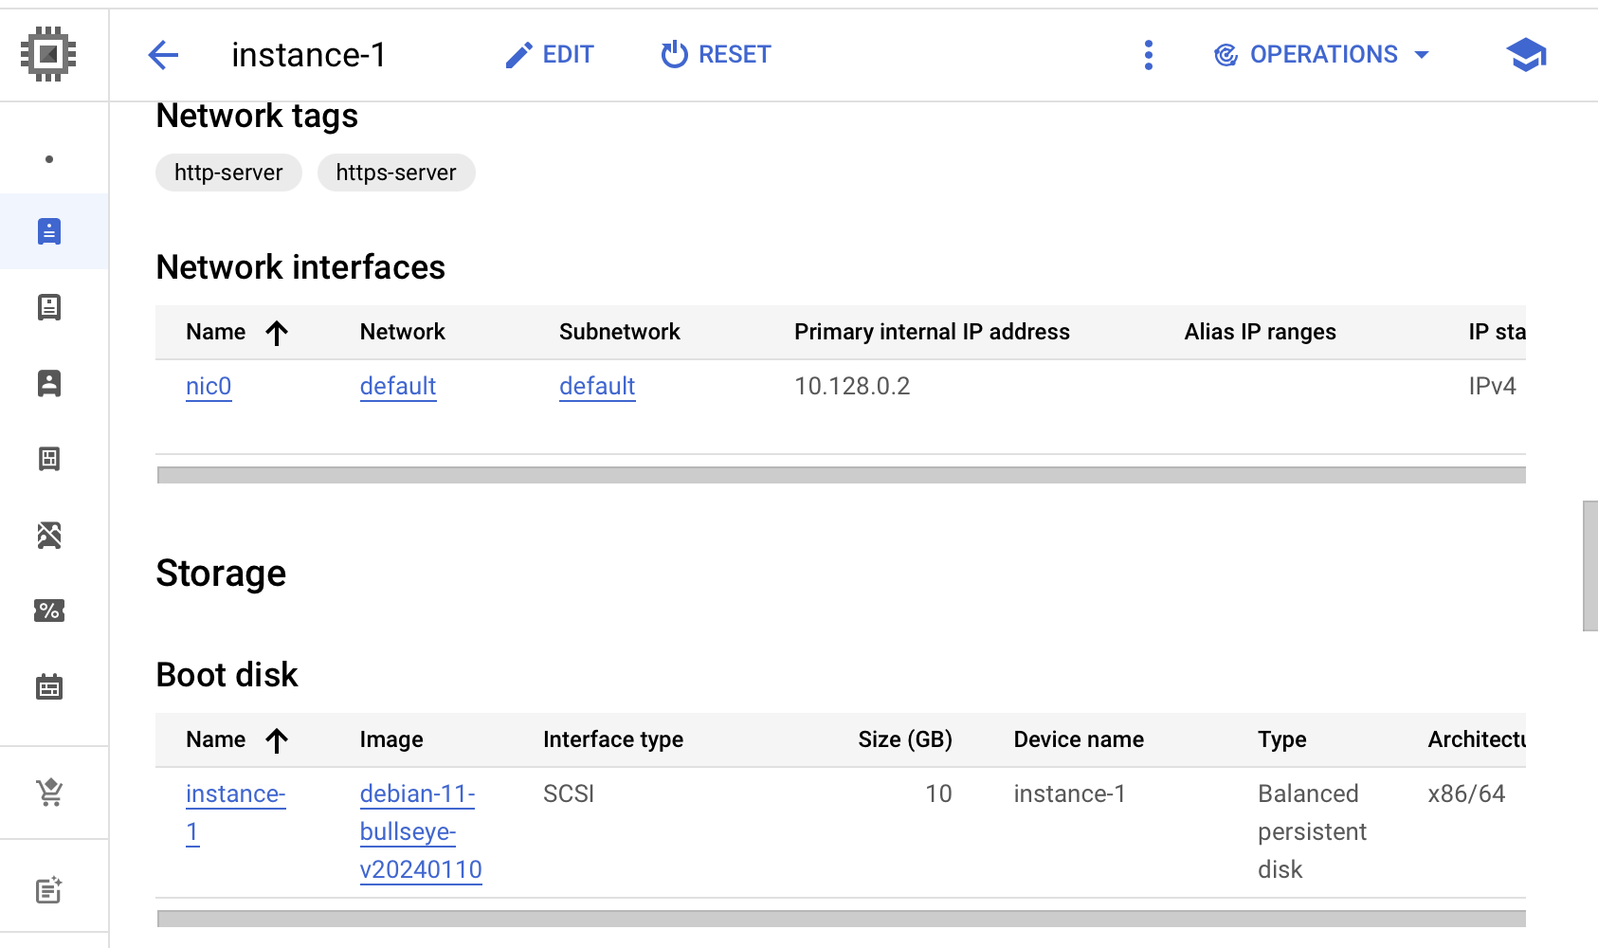

Using web SSH console, to install node, npm.

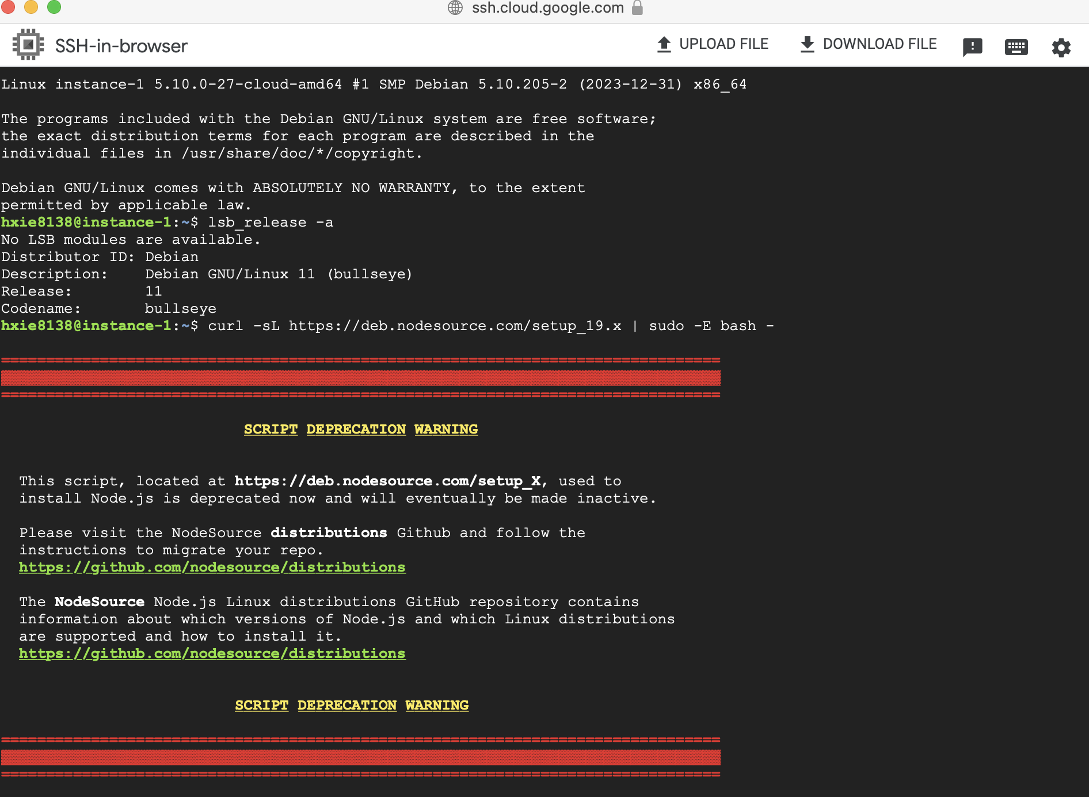

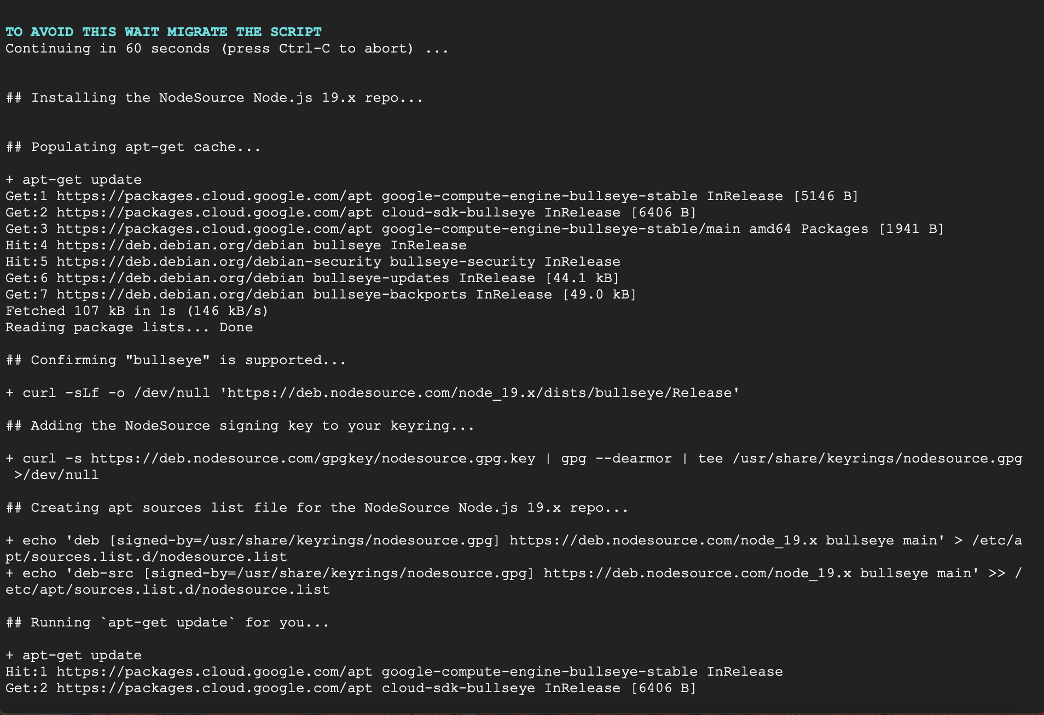

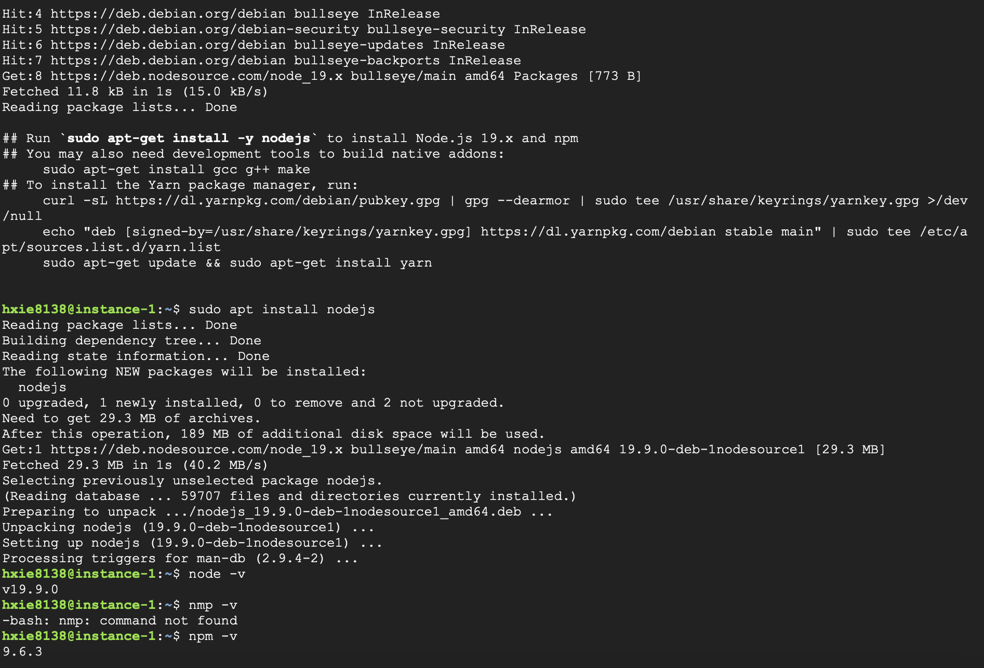

Create a javascript file, copy and paste code into the file.

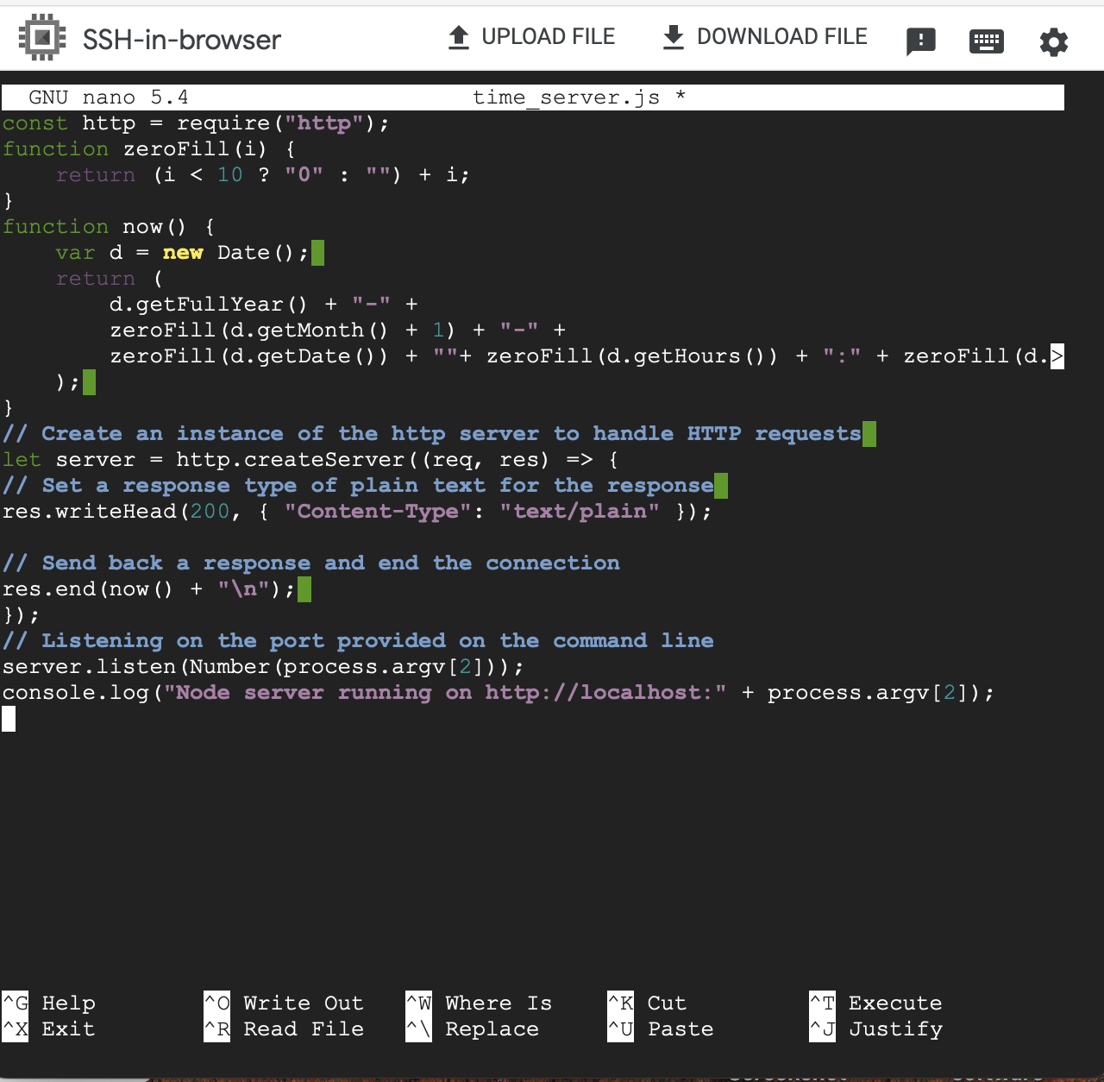



**CS571-Week2-q13-Huijuan Xie-19893**

Check Red/Blue

open the link https://www.w3schools.com/jsref/tryit.asp?filename=tryjsref_radio_checked2

write the following code:

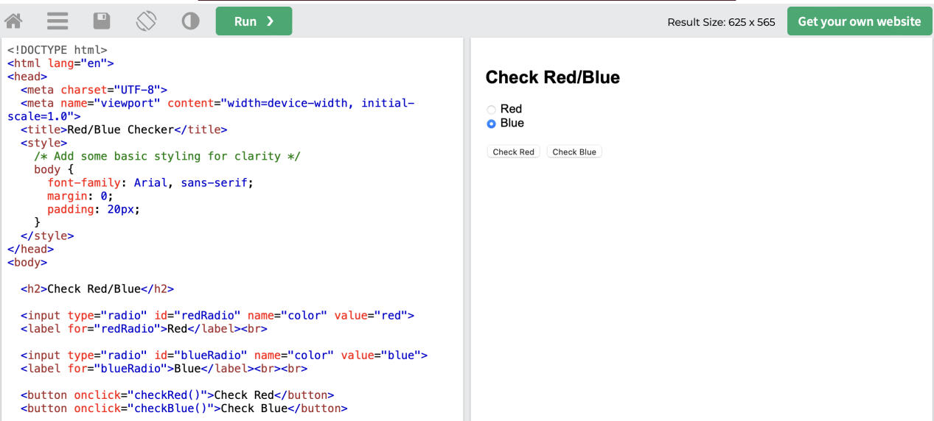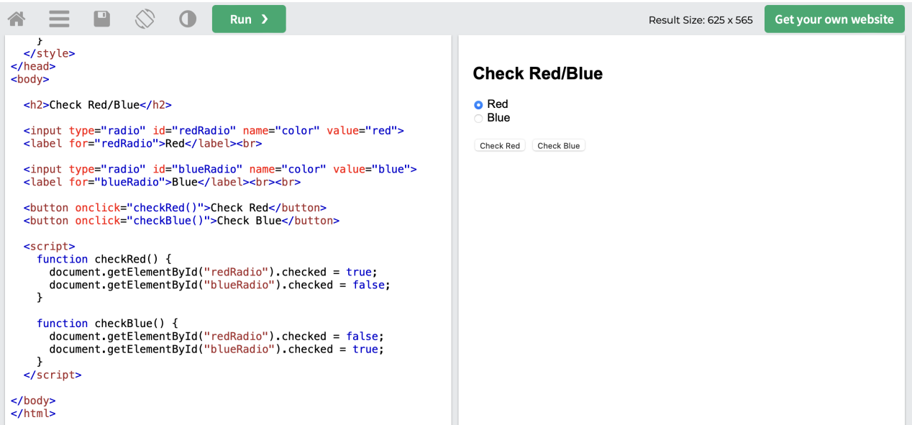

The behavior of this web page is:

If I click the button Check Red, the Red radio button is on, but the Blue radio button is off.

If I click the button Check Blue, the Blue radio button is on, but the Red radio button is off.